# Full Stack Development with MERN — Project Documentation

1. Introduction
Project Title: RentMate — House Rent Management System

2. Project Overview

Purpose

RentMate is a web-based house rental management platform built using the MERN stack. It connects **property owners**, **renters**, and **admins** in one system. Owners list rental properties; renters browse listings and schedule visit appointments; admins monitor users, properties, and visit requests across the platform.

Features

- User registration & login with role-based access (Admin, Owner, Renter)
- Property management — owners can add, view, update, and delete rental listings with images
- Property browsing — renters and public users can search and filter properties by title, address, and city
- Visit appointment booking — renters schedule a date and time to visit a property
- Price negotiation — renters can propose a lower rent; owners accept or reject the offer
- Visit request management — owners approve/reject visit requests; admins can oversee all requests
- Role-based dashboards — separate dashboards for Admin, Owner, and Renter
- Image upload — property photos stored on the server via Multer

3. Architecture

Frontend

The frontend is a **React 18** single-page application (SPA) built with **Vite**.

| Component | Technology |
|-----------|-----------|
| UI Framework | React 18 |
| Build Tool | Vite 5 |
| Routing | React Router v6 |
| HTTP Client | Axios |
| Styling | Custom CSS (`App.css`, `index.css`) |
| State Management | React `useState` / `useEffect` (no Redux) |

Structure:
- `App.jsx` — central route definitions
- `modules/common/` — public pages (Home, Login, Register)
- `modules/admin/` — admin dashboard pages
- `modules/user/owner/` — owner dashboard pages
- `modules/user/renter/` — renter dashboard pages
- `components/` — reusable UI (Navbar, PropertyCard, modals)
- `utils/` — API helpers and formatters

Role-based routing is enforced by the `ProtectedRoute` component, which checks `localStorage` for the logged-in user and their role.

Backend

The backend is a Node.js REST API using Express.js 5.

| Layer | Location | Responsibility |
|-------|----------|----------------|
| Entry Point | `server.js` | App setup, middleware, route mounting |
| Routes | `routes/` | Endpoint definitions |
| Controllers | `controllers/` | Business logic and validation |
| Models | `models/` | Mongoose schemas |
| Uploads | `uploads/upload.js` | Multer configuration for images |

API base URL: http://localhost:8000

Route prefixes:
- /api/users — renter & auth endpoints
- /api/owners — owner property & booking endpoints
- /api/admin — admin management endpoints
- /uploads — static property images

Database

MongoDB is used with **Mongoose ODM**. Database name: `houserentdb`

Collections & Schema

Users Collection
javascript
{
name: String (required),
email: String (required, unique),
password: String (required, hashed),
role: String (enum: "admin" | "owner" | "user", default: "user"),
phone: String,
timestamps: true
}

Properties Collection
javascript
{
title: String (required),
address: String (required),
city: String (required),
owner: ObjectId → User (required),
propertyType: String (enum: "House" | "Apartment" | "Villa"),
price: Number (required),
description: String,
image: String (file path),
timestamps: true
}

Bookings Collection
javascript
{
user: ObjectId → User (required),
property: ObjectId → Property (required),
visitDate: Date (required),
visitTime: String (required),
status: String (enum: "Pending" | "Approved" | "Rejected"),
listedPrice: Number,
proposedPrice: Number,
agreedPrice: Number,
negotiationStatus: String (enum: "None" | "Pending" | "Accepted" | "Rejected"),
timestamps: true
}

Entity Relationships

User (owner) ──1:N──▶ Property
User (renter) ──1:N──▶ Booking ◀──N:1── Property

4. Setup Instructions
Prerequisites

| Software | Version |
|----------|---------|
| Node.js | v18 or higher |
| MongoDB | v6 or higher (local or Atlas) |
| npm | v9 or higher |
| Git | Latest |
Installation

5. Folder Structure

Client

Client/
├── index.html
├── package.json
├── vite.config.js
└── src/
├── main.jsx # React entry point
├── App.jsx # Route definitions
├── App.css # Global styles
├── index.css # CSS variables & base styles
├── components/
│ ├── Navbar.jsx # Public navigation bar
│ ├── DashboardNav.jsx # Dashboard sidebar navigation
│ ├── ProtectedRoute.jsx # Role-based route guard
│ ├── PropertyCard.jsx # Property listing card
│ ├── PropertyDetailsModal.jsx
│ ├── BookPropertyModal.jsx # Visit appointment form
│ └── RenterProfileModal.jsx
├── modules/
│ ├── common/
│ │ ├── Home.jsx # Public landing page
│ │ ├── Login.jsx
│ │ ├── register.jsx
│ │ └── ForgotPassword.jsx
│ ├── admin/
│ │ ├── AdminHome.jsx
│ │ ├── AllUsers.jsx
│ │ ├── AllProperty.jsx
│ │ └── AllBookings.jsx
│ └── user/
│ ├── owner/
│ │ ├── OwnerHome.jsx
│ │ ├── AddProperty.jsx
│ │ ├── AllProperties.jsx
│ │ └── AllBookings.jsx
│ └── renter/
│ ├── RenterHome.jsx
│ ├── AllProperties.jsx
│ └── RenterBookings.jsx
└── utils/
├── api.js # API URL & localStorage helpers
└── formatVisit.js # Visit date/time formatters

Server

Server/
├── server.js # Express app entry point
├── package.json
├── .env # Environment variables
├── config/
│ └── connect.js # MongoDB connection
├── models/
│ ├── UserSchema.js
│ ├── PropertySchema.js
│ └── BookingSchema.js
├── controllers/
│ ├── userController.js # Auth, browse, book visit
│ ├── ownerController.js # Property CRUD, visit management
│ └── adminController.js # Platform-wide management
├── routes/
│ ├── userRoutes.js
│ ├── ownerRoutes.js
│ └── adminRoutes.js
├── uploads/
│ ├── upload.js # Multer configuration
│ └── [property images]
└── scripts/
└── removeSaleProperties.js # Database cleanup utility

6. Running the Application

Terminal 1 — Start Backend
bash
cd Server
npm start

Server runs at: http://localhost:8000

Terminal 2 — Start Frontend
bash
cd Client
npm run dev

Frontend runs at: http://localhost:5173

7. API Documentation

Base URL:http://localhost:8000

User / Auth Routes — /api/users

POST /api/users/signup
Register a new user.

Request Body:
json
{
"name": "John Doe",
"email": "john@example.com",
"password": "password123",
"phone": "9876543210",
"role": "user"
}

Response (201):
json
{
"_id": "...",
"name": "John Doe",
"email": "john@example.com",
"phone": "9876543210",
"role": "user"
}

POST /api/users/login
Authenticate a user.

Request Body:
json
{
"email": "john@example.com",
"password": "password123"
}

Response (200):
json
{
"_id": "...",
"name": "John Doe",
"email": "john@example.com",
"role": "user",
"phone": "9876543210"
}

POST /api/users/forgot-password
Request password reset (stub implementation).

Request Body:
json
{ "email": "john@example.com" }

Response (200):
json
{
"message": "If an account exists, password reset instructions have been sent to your email."
}

GET /api/users/properties
Browse all rental properties.

Response (200):
json
[
{
"_id": "...",
"title": "2BHK Apartment",
"address": "123 Main Street",
"city": "Mumbai",
"price": 25000,
"propertyType": "Apartment",
"description": "Spacious 2BHK...",
"image": "uploads/1234567890-photo.jpg",
"owner": { "name": "Owner Name", "email": "owner@example.com" }
}
]

POST /api/users/book-property
Schedule a property visit appointment.

Request Body:
json
{
"user": "userId",
"property": "propertyId",
"visitDate": "2026-06-20",
"visitTime": "14:30",
"proposedPrice": 22000
}
```

Response (201):
json
{
"_id": "...",
"user": { "name": "John Doe", "email": "john@example.com" },
"property": { "title": "2BHK Apartment", "city": "Mumbai", "price": 25000 },
"visitDate": "2026-06-20T00:00:00.000Z",
"visitTime": "14:30",
"status": "Pending",
"listedPrice": 25000,
"proposedPrice": 22000,
"negotiationStatus": "Pending"
}
GET /api/users/my-bookings?userId=<id>
Get all visit requests for a renter.

Query Parameters: userId(required)

Response (200): Array of booking objects with populated property details.

Owner Routes — /api/owners

POST /api/owners/property
Add a new rental property (multipart/form-data).

Form Fields:

| Field | Type | Required |
|-------|------|----------|
| title | string | Yes |
| address | string | Yes |
| city | string | Yes |
| price | number | Yes |
| propertyType | string | Yes |
| description | string | No |
| owner | string (userId) | Yes |
| image | file | No |

Response (201): Created property object.

GET /api/owners/properties?ownerId=<id>
Get properties listed by an owner.

Query Parameters:ownerId (optional)

PUT /api/owners/property/:id
Update a property.
Request Body: Any updatable property fields.

DELETE /api/owners/property/:id
Delete a property.

Response (200):
json
{ "message": "Property deleted successfully" }

GET /api/owners/bookings?ownerId=<id>
Get visit requests for an owner's properties.

Query Parameters:ownerId (required)

PUT /api/owners/booking/:id
Approve or reject a visit request.

Request Body
json
{
"ownerId": "ownerId",
"status": "Approved"
}
PUT /api/owners/booking/:id/negotiation
Accept or reject a price negotiation offer.

Request Body:
json
{
"ownerId": "ownerId",
"action": "Accept"
}
Admin Routes — /api/admin

GET /api/admin/users
List all registered users (password excluded).

GET /api/admin/properties
List all properties with owner details.

GET /api/admin/bookings
List all visit requests across the platform.

PUT /api/admin/booking/:id
Update any visit request status.

Request Body:
json
{ "status": "Approved" }

8. Authentication

Authentication Method

The project uses client-side session storage with bcrypt password hashing. JWT tokens are not used.

Registration Flow
1. User submits the registration form with name, email, password, phone, and role.
2. Backend checks if the email already exists.
3. Password is hashed using bcryptjs(salt rounds: 10).
4. User document is saved to MongoDB.
5. User object (without password) is returned to the client.

Login Flow
1. User submits email and password.
2. Backend finds the user by email.
3. Password is verified with bcrypt.compare().
4. On success, the user object is stored in localStorage:
javascript
localStorage.setItem("user", JSON.stringify(userData));

5. User is redirected based on role:
- admin → /admin
- owner` → /owner
- user (renter) → /renter

Authorization
Role-based access is enforced on the **frontend** via the ProtectedRoute component:

javascript
<ProtectedRoute allowedRoles={["owner"]}>
<OwnerHome />
</ProtectedRoute>

| Role | Access |
|------|--------|
| `admin` | Admin dashboard, all users/properties/bookings |
| `owner` | Owner dashboard, own properties & visit requests |
| `user` | Renter dashboard, browse properties, schedule visits |

9. User Interface

Public Pages

| Page | Route | Description |
|------|-------|-------------|
| Home | `/` | Landing page with property search, sort, and browse |
| Login | `/login` | User authentication |
| Register | `/register` | New user registration |
| Forgot Password | `/forgot-password` | Password recovery form |
| Browse Properties | `/properties` | Public property listing |

Admin Dashboard

| Page | Route | Description |
|------|-------|-------------|
| Dashboard | `/admin` | Platform statistics (users, properties, visit requests) |
| All Users | `/admin/users` | View all registered users |
| All Properties | `/admin/properties` | View all listed properties |
| Visit Requests | `/admin/bookings` | Manage all visit appointments |

Owner Dashboard

| Page | Route | Description |
|------|-------|-------------|
| Dashboard | `/owner` | Property and visit request counts |
| Add Property | `/owner/add-property` | Form to list a new rental property |
| My Properties | `/owner/properties` | View and delete own listings |
| Visit Requests | `/owner/bookings` | Review, approve/reject visits and price offers |

Renter Dashboard

| Page | Route | Description |
|------|-------|-------------|
| Dashboard | `/renter` | Available properties and visit count stats |
| Browse | `/renter/properties` | Search and schedule property visits |
| My Visits | `/renter/bookings` | Track visit appointment status |

Key UI Components
-PropertyCard — displays property image, title, location, price, and type badge
- BookPropertyModal— visit date/time picker with optional price negotiation
- PropertyDetailsModa — full property details with Schedule Visit button
- RenterProfileModal — renter contact info and visit details for owners

10. Testing
Current Status
Automated testing is not yet implemented in this project. The package.json test script is a placeholder.

Recommended Testing Strategy

| Type | Tool | Scope |
|------|------|-------|
| Unit Tests | Jest | Controllers, utility functions |
| API Tests | Supertest + Jest | All REST endpoints |
| Component Tests | React Testing Library | Forms, modals, route guards |
| E2E Tests | Cypress or Playwright | Full user flows (login → book visit) |

Manual Testing Checklist

- [ ] Register as Owner, Renter, and Admin
- [ ] Login with correct and incorrect credentials
- [ ] Owner adds property with and without image
- [ ] Renter browses and searches properties
- [ ] Renter schedules visit with and without price negotiation
- [ ] Owner approves/rejects visit requests
- [ ] Owner accepts/rejects price offers
- [ ] Admin views all users, properties, and bookings
- [ ] Role-based route protection (wrong role redirected)

11. Screenshots or Demo
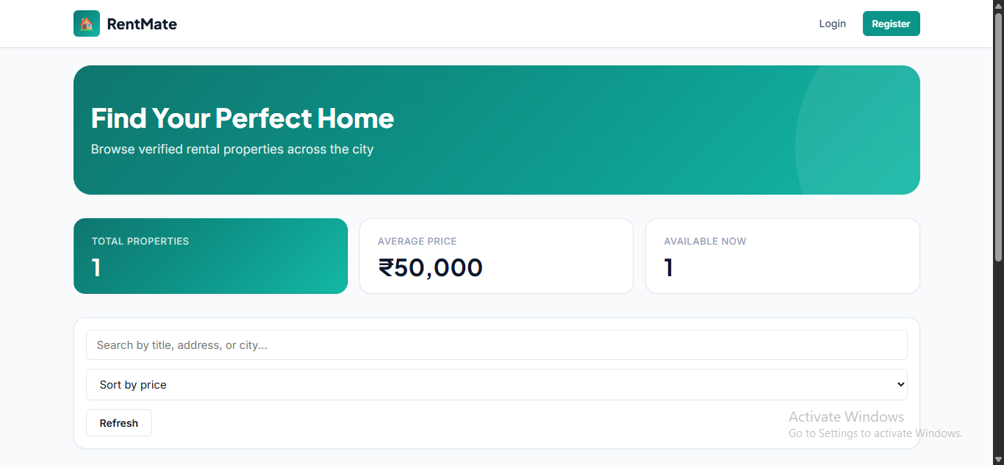

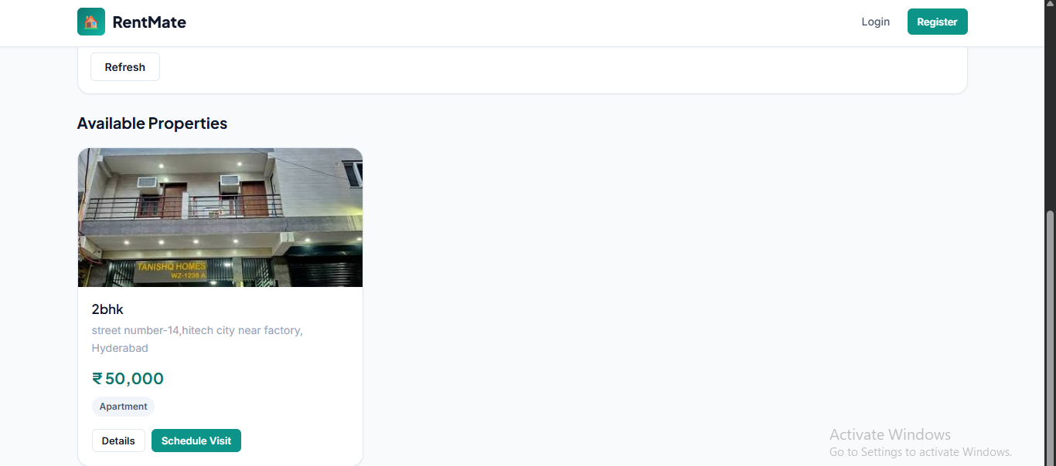

12. Known Issues

| # | Issue | Severity | Description |
|---|-------|----------|-------------|
| 1 | No server-side auth middleware | High | API endpoints do not verify JWT/session; user IDs are passed from the client and can be spoofed |
| 2 | Forgot password is a stub | Medium | Password reset endpoint returns a success message but does not send email |
| 3 | No input sanitization | Medium | User inputs are not sanitized against XSS or injection |
| 4 | No visit slot conflict check | Low | Multiple renters can book the same date/time for the same property |
| 5 | No email notifications | Low | Owners/renters are not notified when visit status changes |
| 6 | Images stored locally | Low | Uploaded images are stored on the server filesystem; not suitable for cloud deployment without changes |
| 7 | Legacy plain-text passwords | Low | Login supports legacy unhashed passwords for backward compatibility |

13. Future Enhancements

| Feature | Description |
|---------|-------------|
| JWT Authentication | Secure API with token-based auth and refresh tokens |
| Email Notifications | Notify owners and renters on visit status changes |
| Real-time Chat | In-app messaging between renter and owner |
| Visit Slot Management | Prevent double-booking of the same time slot |
| Property Reviews & Ratings | Renter feedback after property visits |
| Advanced Search Filters | Filter by price range, property type, city, amenities |
| Payment Integration | Online rent payment via Razorpay/Stripe |
| Google Maps Integration | Show property location on an interactive map |
| Admin Analytics Dashboard | Charts for bookings, revenue, and user growth |
| Cloud Image Storage | Migrate uploads to AWS S3 or Cloudinary |
| Mobile Responsive PWA | Progressive Web App for mobile users |
| Automated Testing | Jest + Supertest + Cypress test suite |

